Constructor and Named constructor

Workshop #2

Flutter Developer Bootcamp

# **Purpose**

This workshop demonstrates the use of constructors and methods within a class, showcasing both default and named constructors, as well as method invocation.

**Problem**

In the given workshop demonstrates the object-oriented principles through class constructors and method invocations. In the main function, instances of the cs class are created using both default (cs()) and named (cs.name()) constructors. The cs class includes methods and constructors that illustrate Dart's support for flexible object initialization and method implementation, emphasizing fundamental concepts like encapsulation and constructor overloading You need to print the message ‘This is from Default control’.

**How to Solve**

1. Checkout the workshop from Git Repo:

git clone -b <user-branch> <repo-URL>

1. Open the root folder inside VS Code
2. Open the root folder in terminal
3. Run the command dart run filename.dart
4. Main Function:

* Creates instances of the cs class using both default (cs()) and named (cs.name()) constructors.

1. Default Constructor (cs()):

* Prints 'This is from Default control' when an instance is created using cs() in the main function.
* Demonstrates Dart's support for initializing objects with specific behavior upon creation.

1. Named Constructor (cs.name()):

* Defined in the cs class but currently does not have additional functionality in the provided code.

1. Object-Oriented Principles:

* Methods and constructors encapsulate behavior within the cs class.
* Constructor Overloading: Shows Dart's capability to have multiple constructors (cs() and cs.name()).
* Method Invocation: Though not explicitly demonstrated in the provided code, methods can be defined within cs to perform actions on instances created.

1. Object Initialization:

* Illustrates Dart's flexibility in managing object initialization through various constructor types (default and named).

1. Go To File: <specific-file--method> à <method-name>, implement your logic.

**You will Achieve**

When you complete this workshop you will learn the following:

**Methods and Functions Used:**

* **Constructor Methods:**
* cs(): Default constructor that initializes instances and prints 'This is from Default control'.
* cs.name(): Named constructor, currently without additional functionality.
* **Other Possible Methods:**
* Additional methods can be included within the cs class to perform specific actions on instances.
* **Main Function:**
* Creates instances using constructors, showcasing how objects are initialized and constructors are invoked.

# **Screenshots**

## **Before implementation (without printing message)**

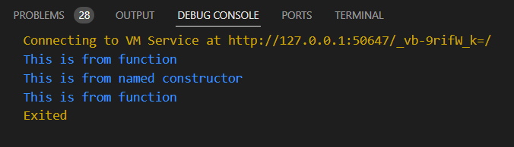

## **After implementation (with printing message)**

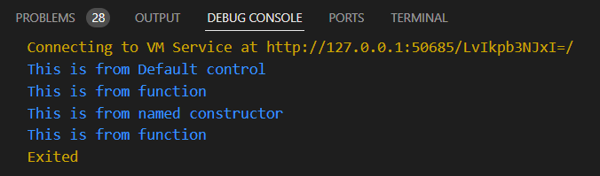

# **How to submit your workshop**

Push your project back to the same git branch using command:

<command name>

# **Happy Coding!**